Class test

1. Observe the diagram showing three objects (1, 2, and 3) of the same size and shape but made of different materials, placed in water.

Each object sinks to a different depth, as shown in the figure. Let their respective weights be W1, W2, and W3

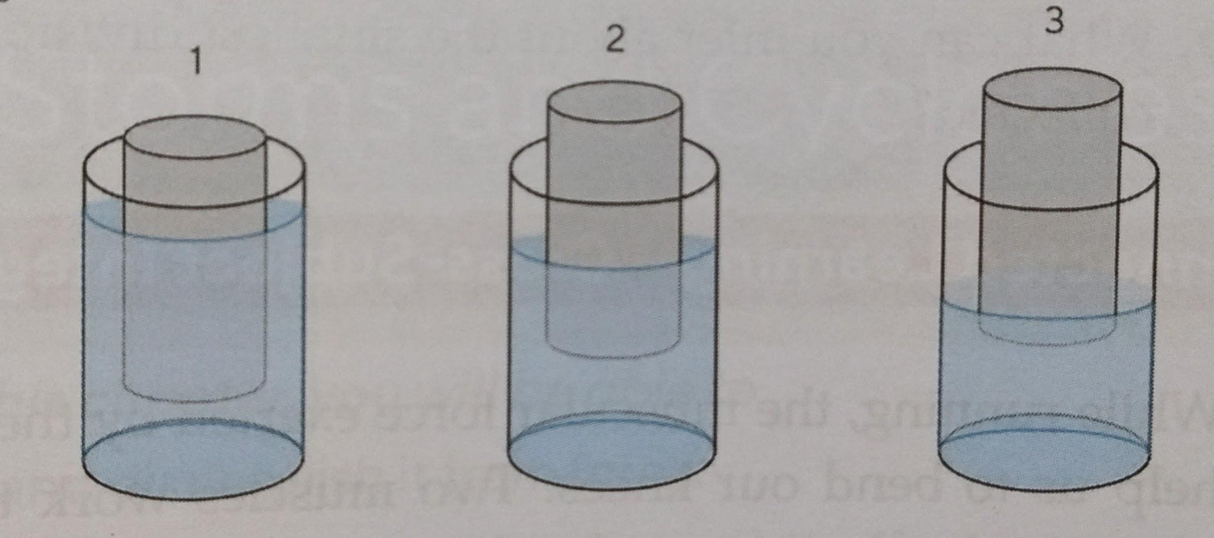

Which of the following is most likely true? (1)

a W1 = W2 = W3 b. W1 <W2 <W3 c. W1 > W2> W3 d. W1 = W2> W3

2. A man with a parachute moves down due to the gravitational pull of the Earth. Another opposing force acts on the parachute in the opposite direction of its motion. This opposing force is known as air resistance. How will the air resistance acting on the parachute affect its motion?(1)

3. Hemant sets up an experiment where he releases a ball from point A on an inclined plane. The ball rolls down and moves along a smooth horizontal surface, finally coming to rest at point X.

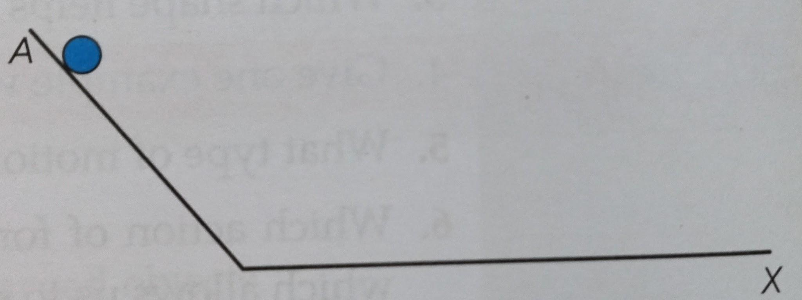
X Hemant conducts the experiment again under a different condition. This time the ball stops before reaching point A. Suggest one possible change Hemant might have made.

4. (A): A ball falls to the ground when thrown upward.
(R): Earth pulls all objects towards its centre with a gravitational force.

5. (A): A balloon sticks to a wall after being rubbed with hair.
(R): The balloon becomes magnetised after rubbing and gets attracted to the wall.

6. (A): The friction between surfaces is always the same regardless of their roughness.
(R): Friction arises due to the interlocking of irregularities between surfaces.
7. (A): A ball moves faster when pushed in the direction of its motion.
(R): Force applied in the direction of motion increases the speed of an object.

8. (A): Muscular force is a contact force.
(R): Muscular force is caused by the contraction and relaxation of muscles in our body.

9. If the weight of the object on planet X is 81N and acceleration due to gravity is 9 m/ s2. Then calculate (1+1+1)
- Mass of the object.
- Weight of the same object on planet earth ( take g= 10m/s2)
- Weight of the object on moon

10. A. Find the value of A, B and C in spring banlace. (3 ½ )
B. Determine the value of one small division for mass and weight. (1 ½ )

Grams | Newton
0 | 0
A | 7
B | 14
C | 21

